**Practical No. 4**

1. **Using Packet Tracer, create a basic network of One server and two computers and two mobile / movable devices using appropriate network wire. Show connectivity.**

**Step 1: Select ‘End Devices’ and select ‘Server’**

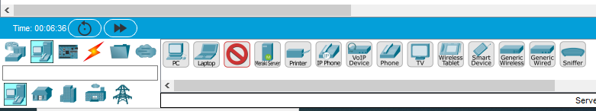

**Step 2: Drag and drop the ‘Server’**

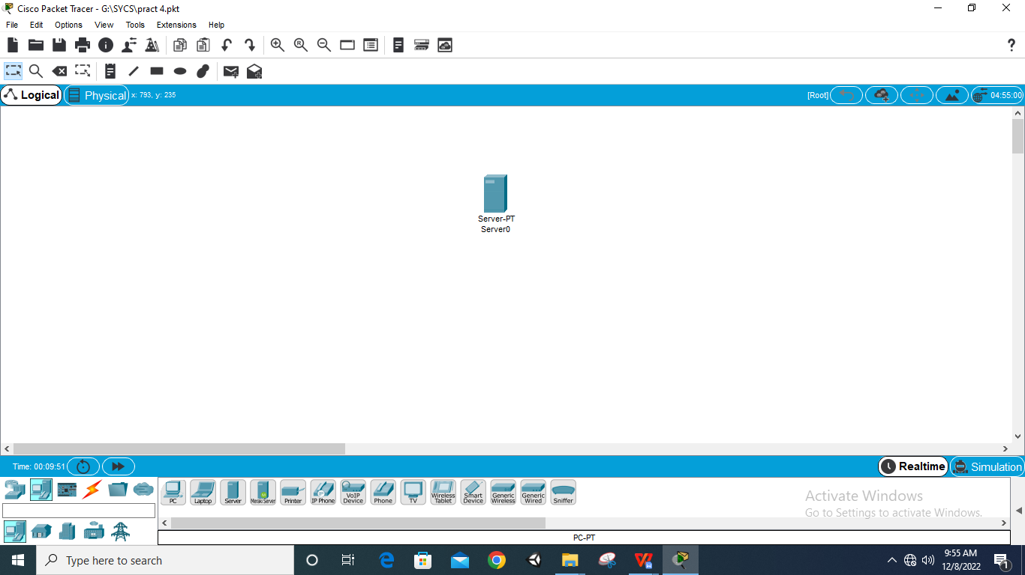

**Step 3: Select ‘Network Devices’, select ‘Switch’ and select ‘PT Switch’**

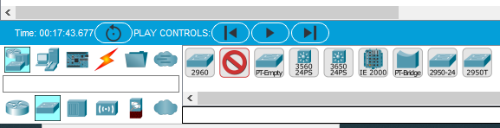

**Step 4: Drag and drop the ‘PT Switch’**

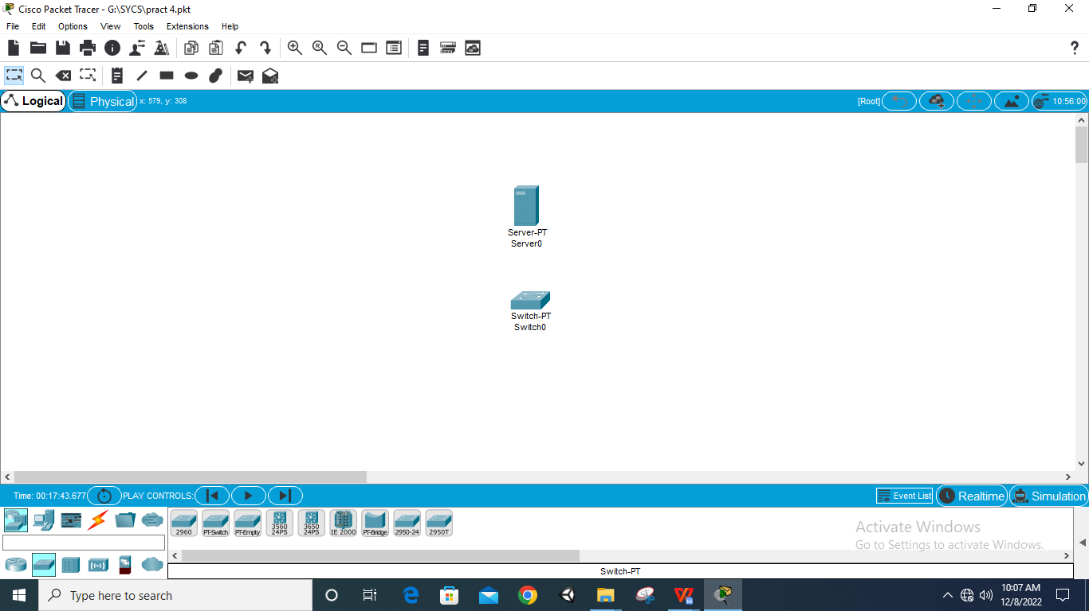

**Step 5: Select ‘End Devices’ and select ‘PC’ and ‘Laptop’**

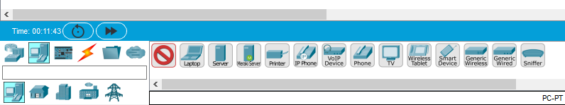

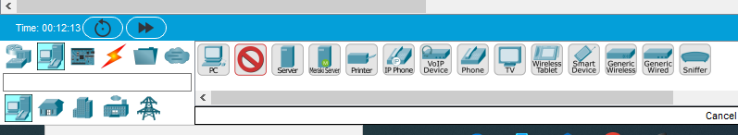

**Step 6: Drag and drop 3 ‘PC’s and 2 ‘Laptop’s**

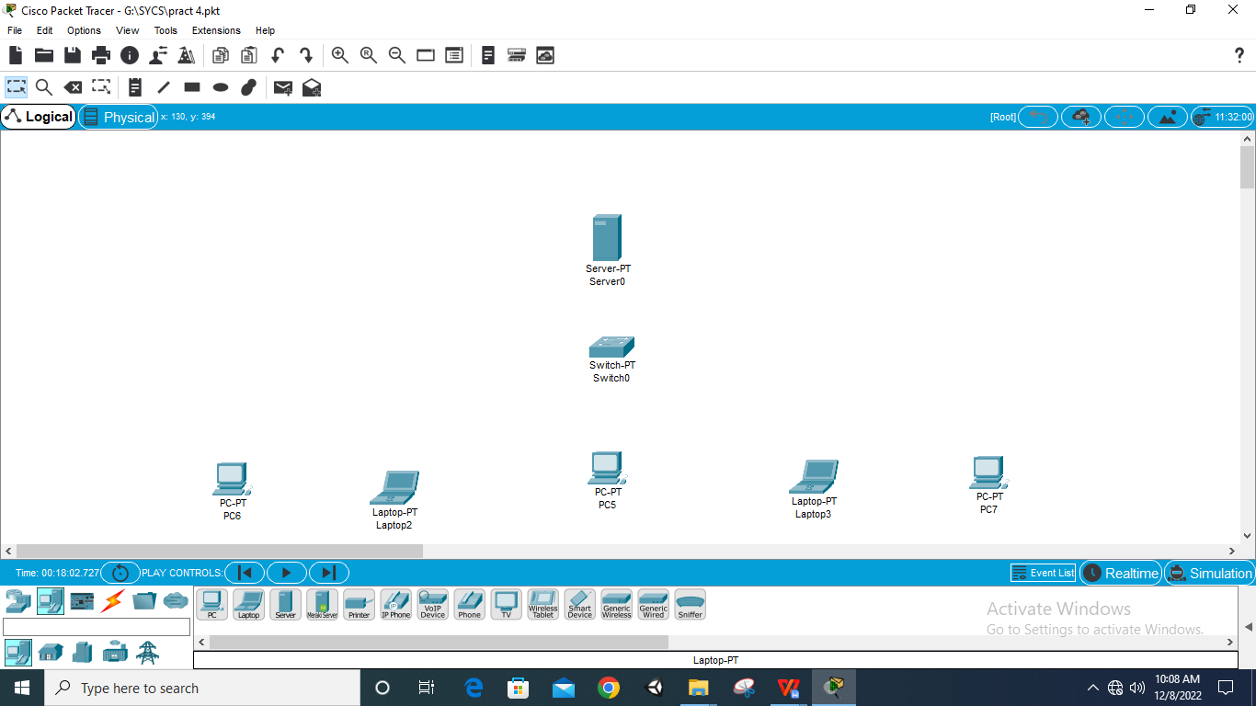

**Step 7: Select ‘Connections’ and select ‘Copper Straight Through’**

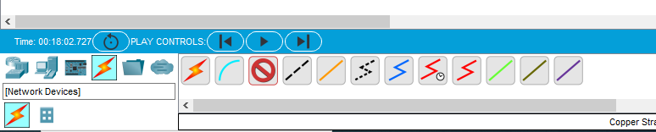

**Step 8: Connect all devices with fastethernet**

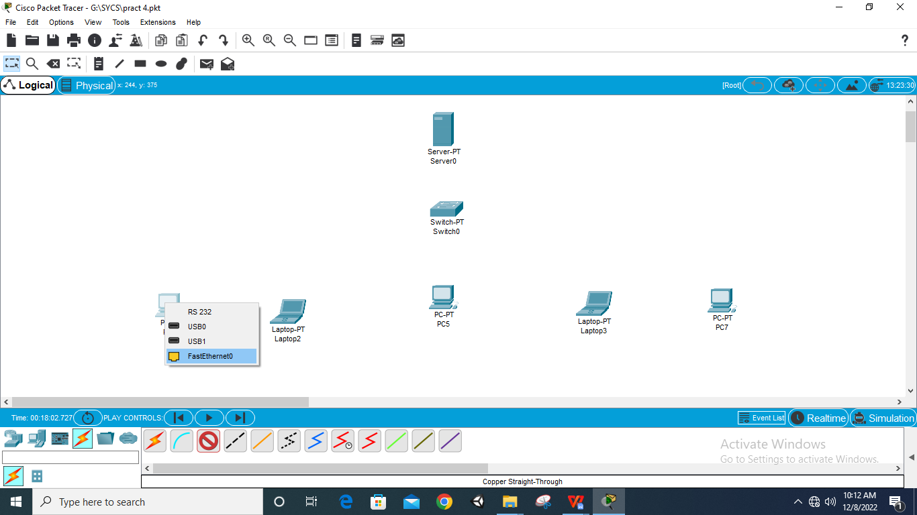

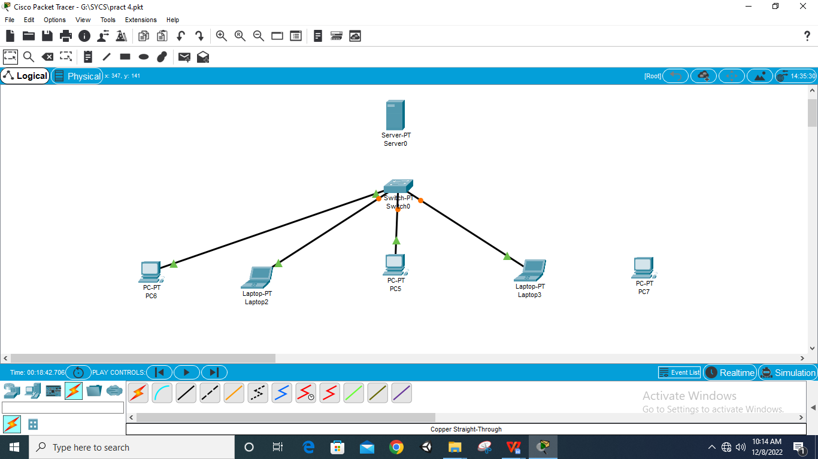

**Step 9: Off the switch by clicking on ‘PT Switch’ and ‘Physical’**

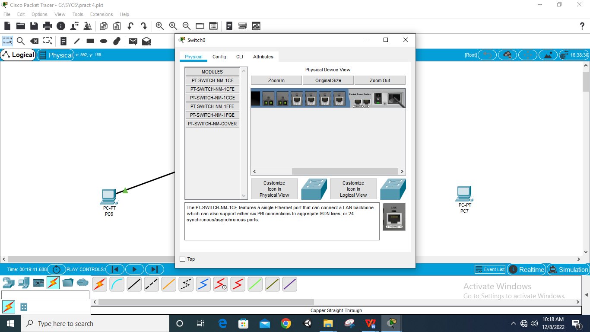

**Step 10: Add two ports to the ‘PT Switch’**

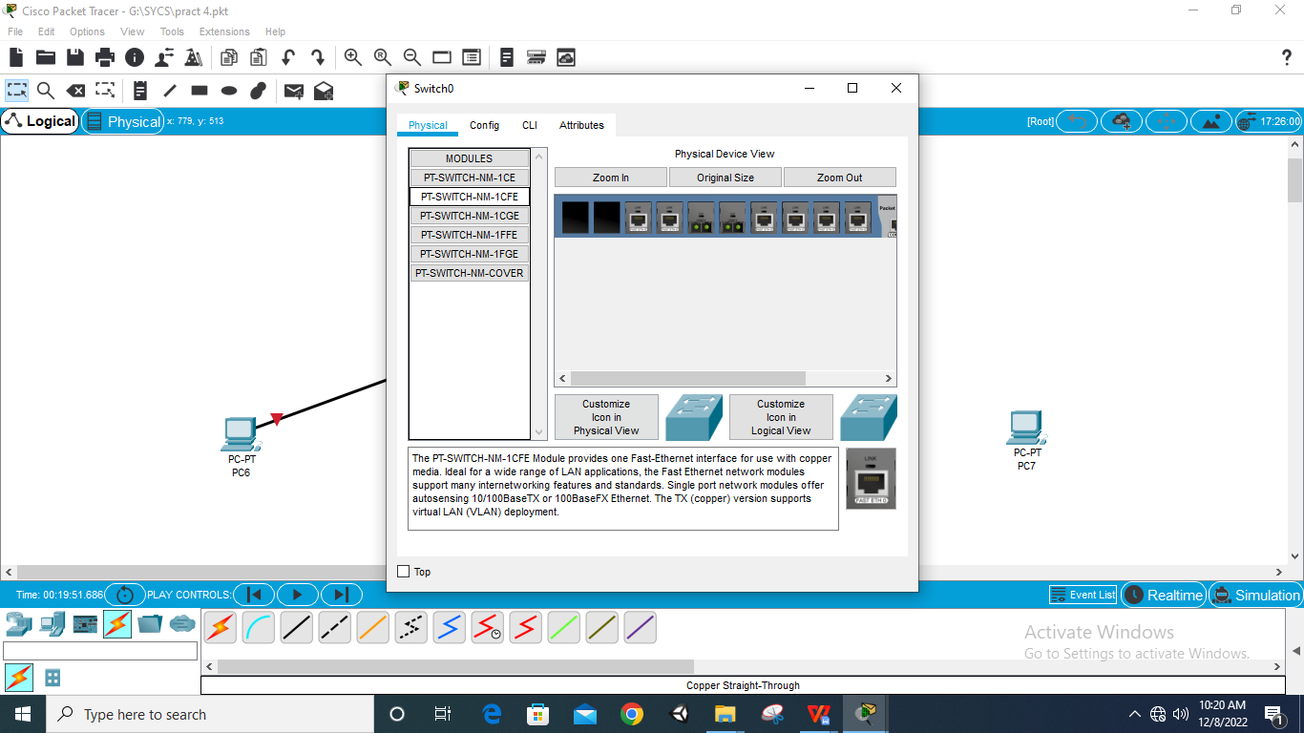

**Step 11: On the Switch**

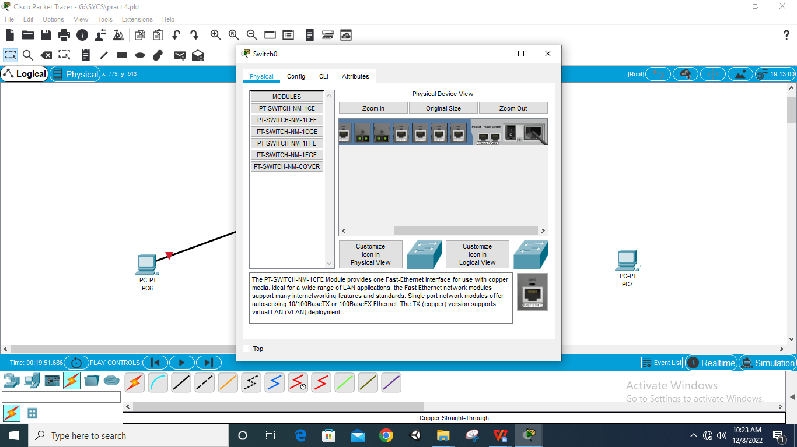

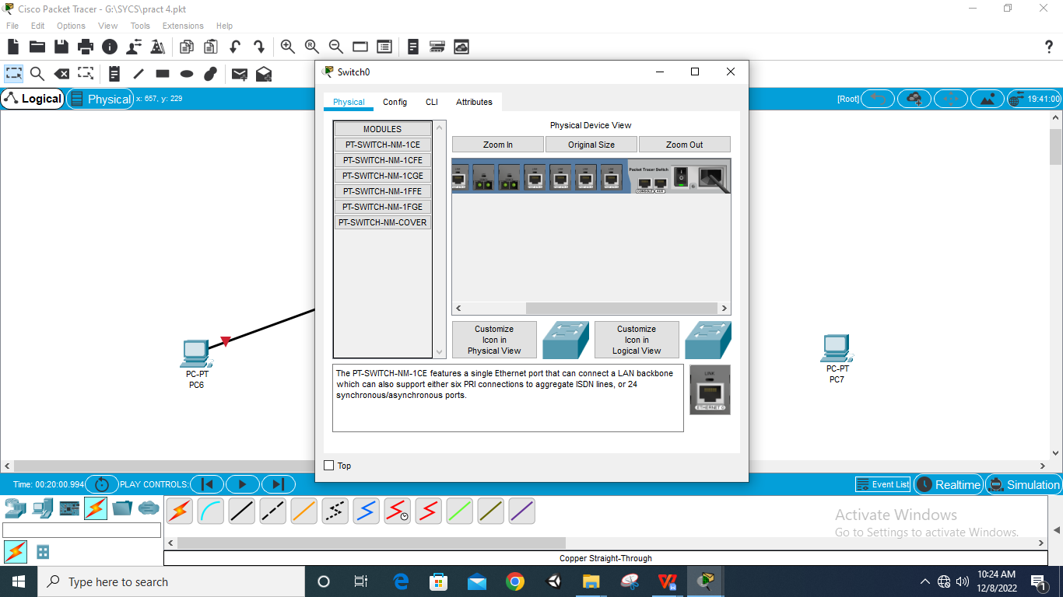

**Step 12: Connect remaining devices with fastethernet**

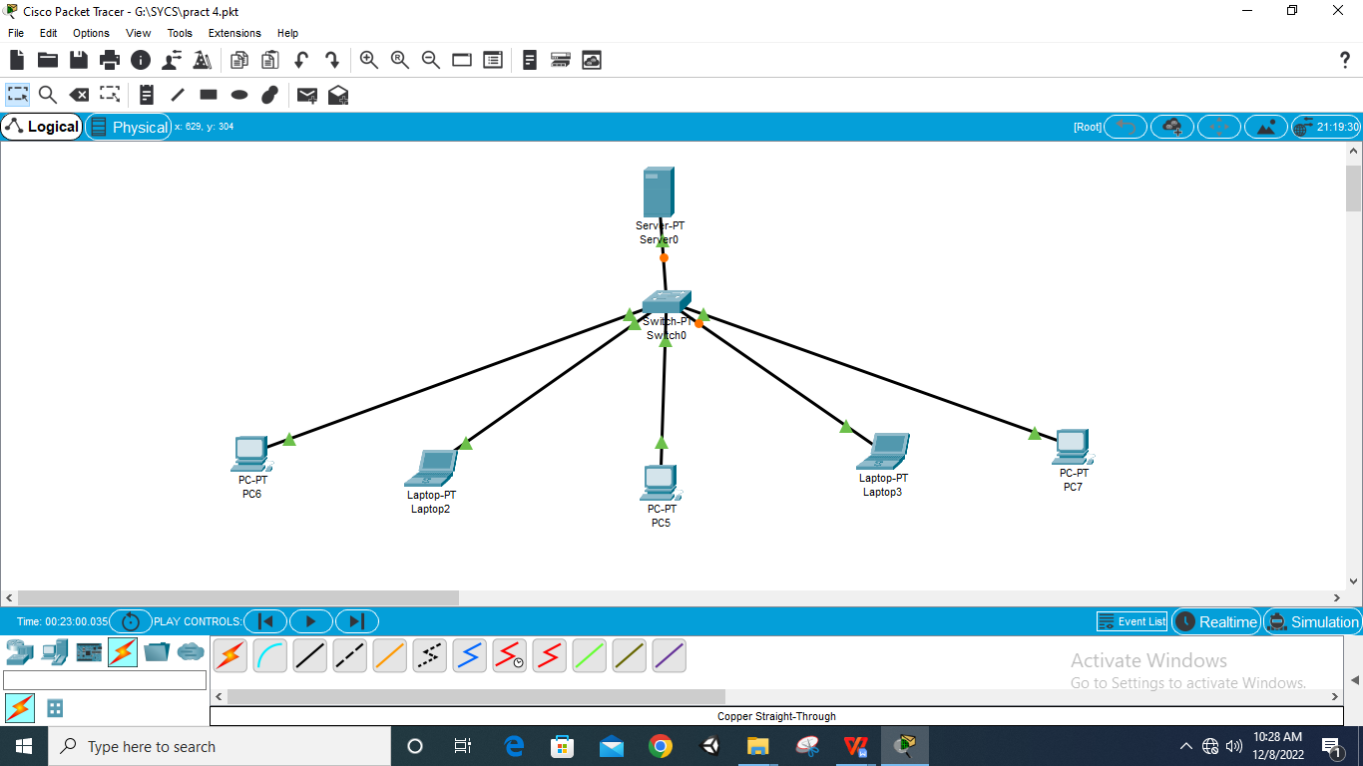

**Step 13: Give start IP name 192.168.0.0**

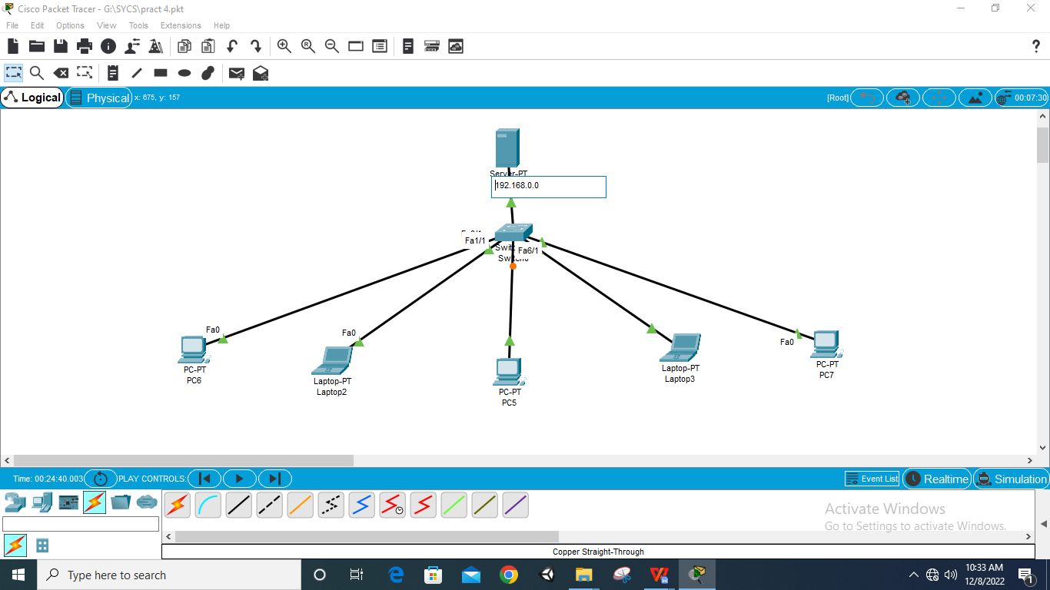

**Step 14: Select ‘Server’ and go to ‘IP Configuration’**

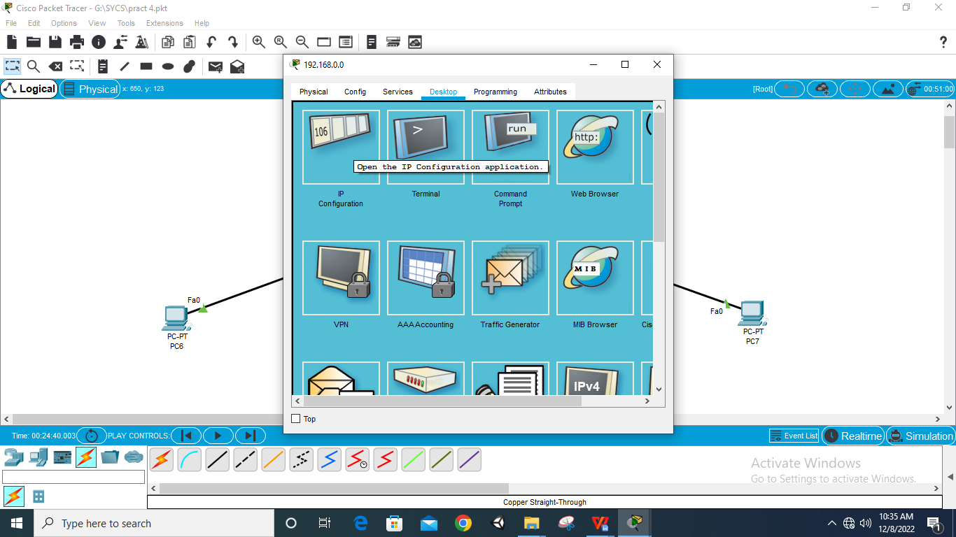

**Step 15: Go to ‘Desktop’ give ‘Static IP’ and ‘subnet nask’**

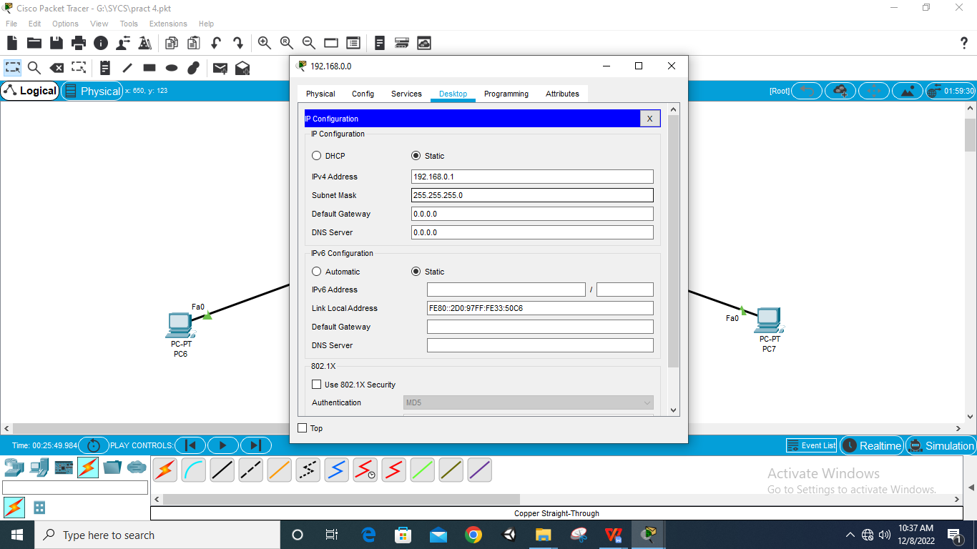

**Step 16: Go to ‘Services’ and give default gateaway and DNS**

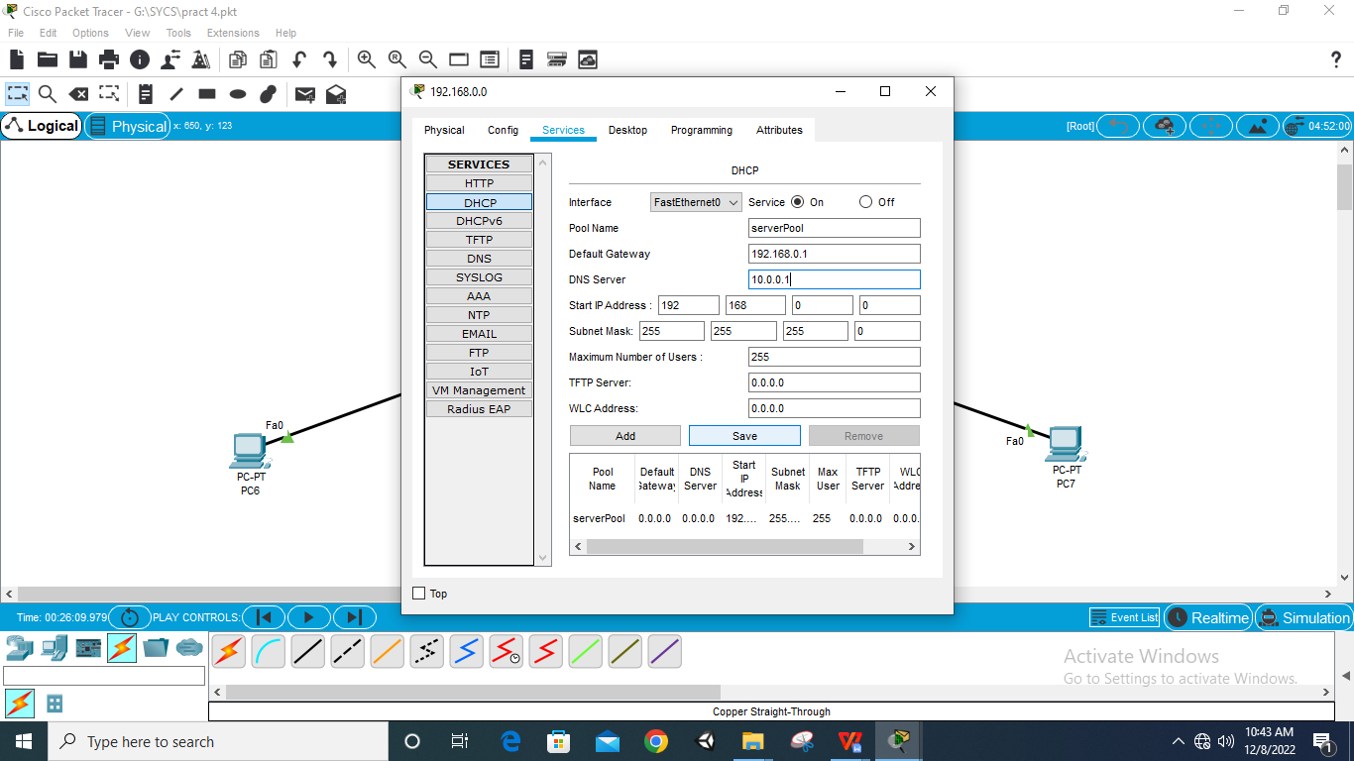

**Step 17: Click ‘save’**

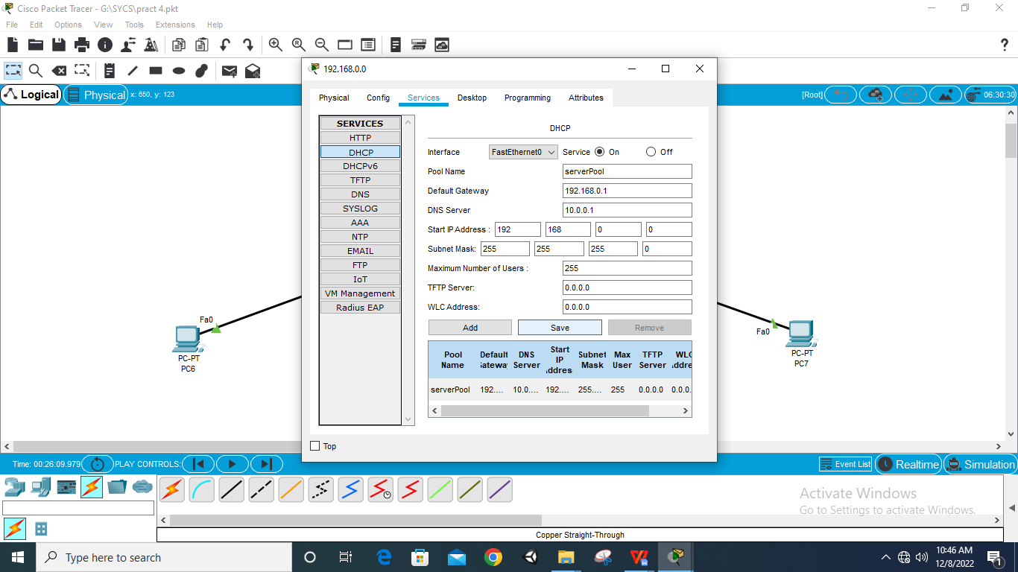

**Step 18: Select every PC, Laptop and select DHCP**

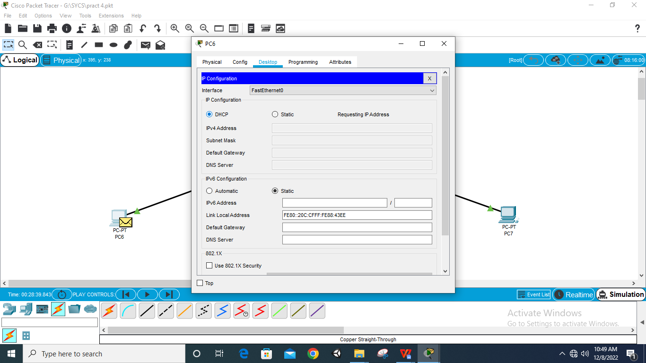

**Step 19: Connections Completed**

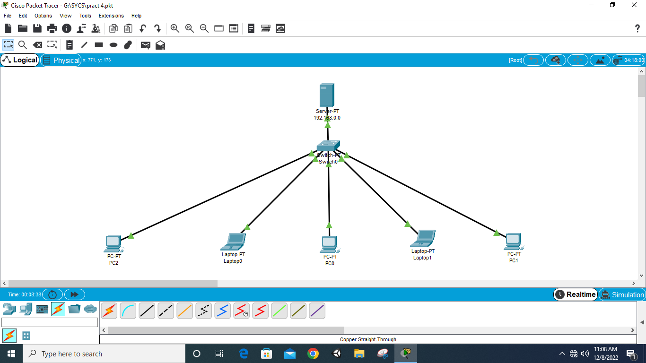

**Step 20: Assign Packets**

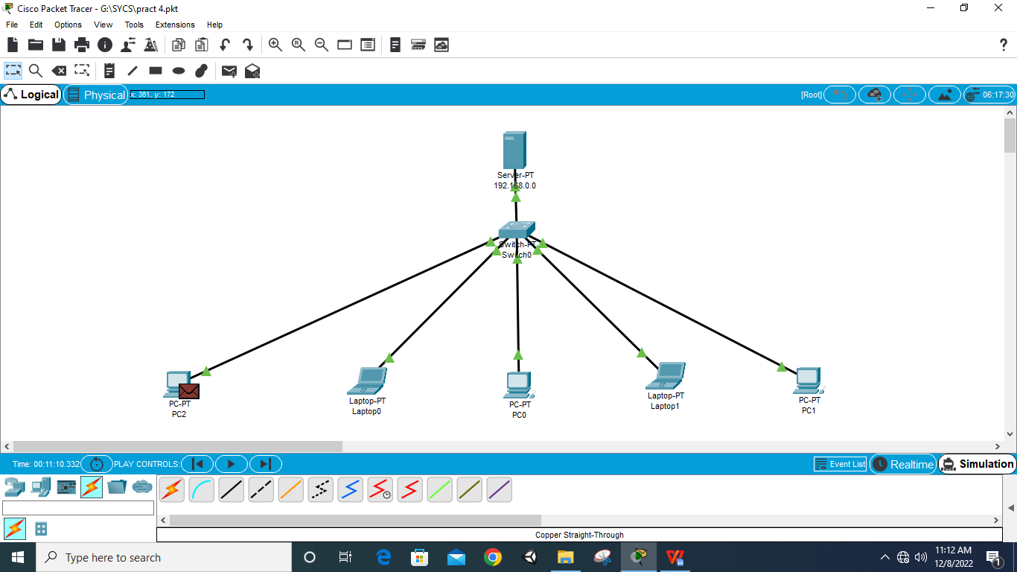

**Step 21: Run Simulation**

